**Evidence for Analysis and Design Unit**

Name: Dan Kelsey

Cohort: E15

01/09/17

**AD 1 – Create a Use Case diagram**

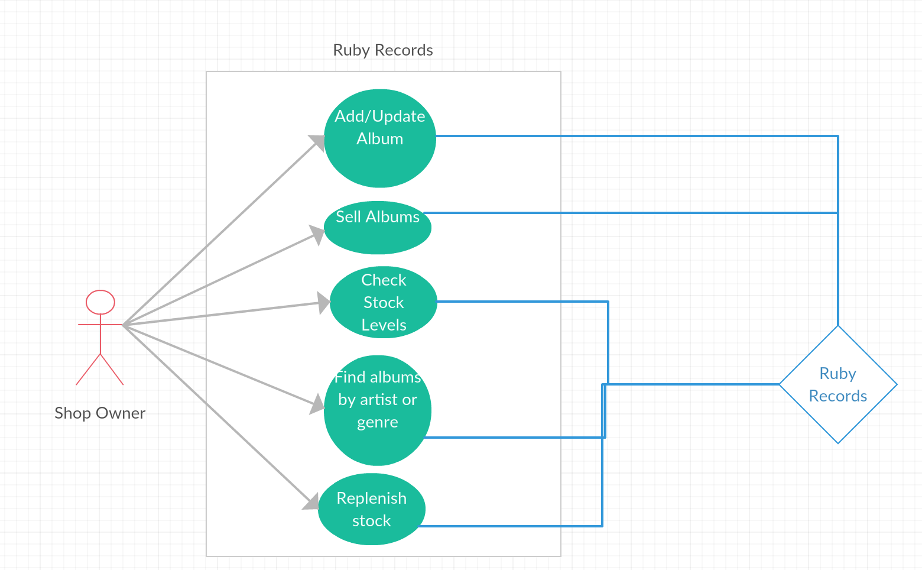

**AD 2 – Create a Class diagram using your Use Case diagram**

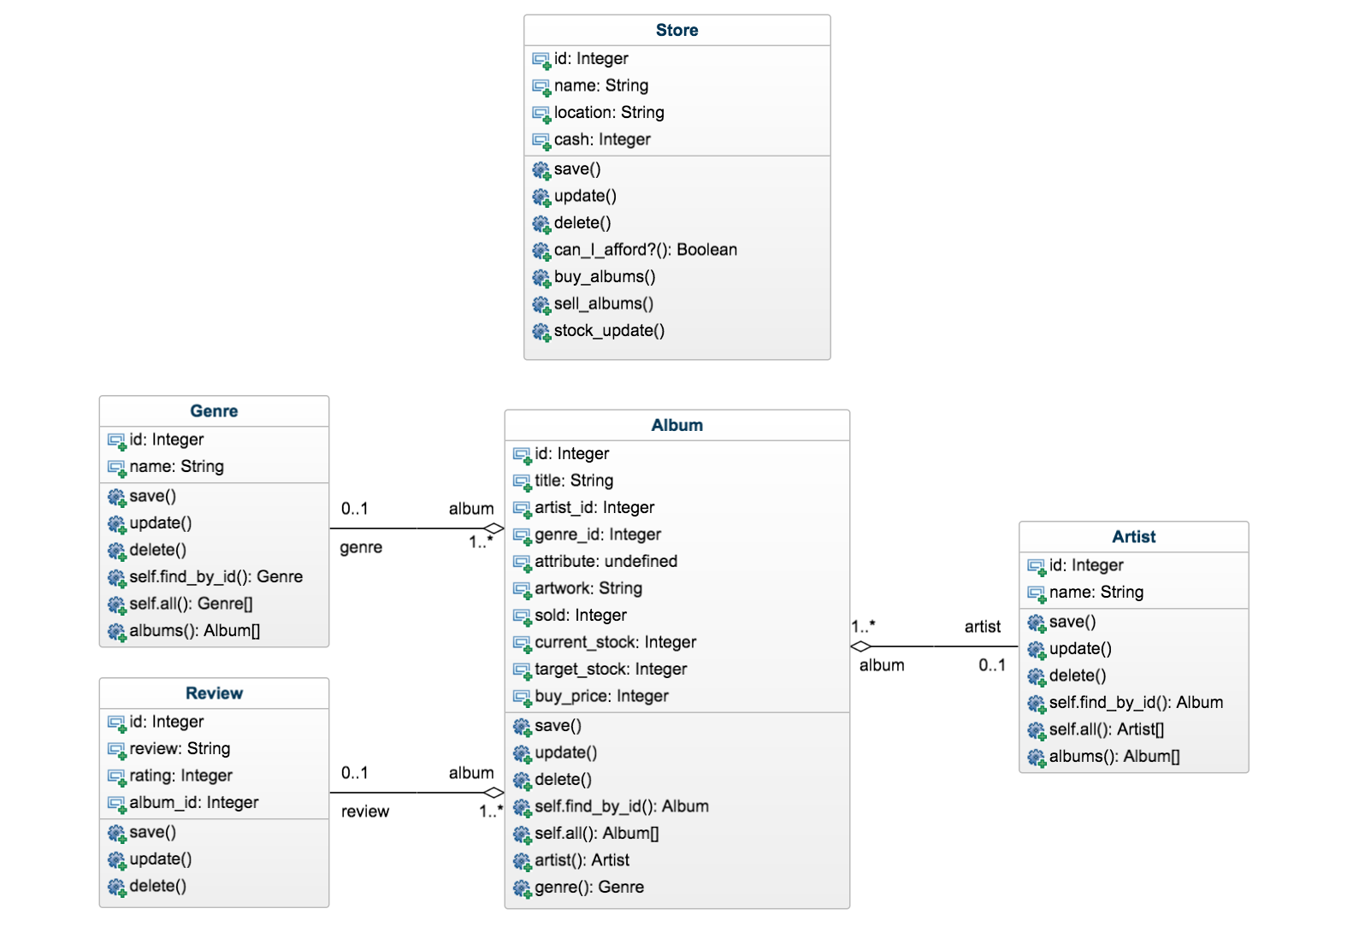

**AD 3 – Object Diagram**

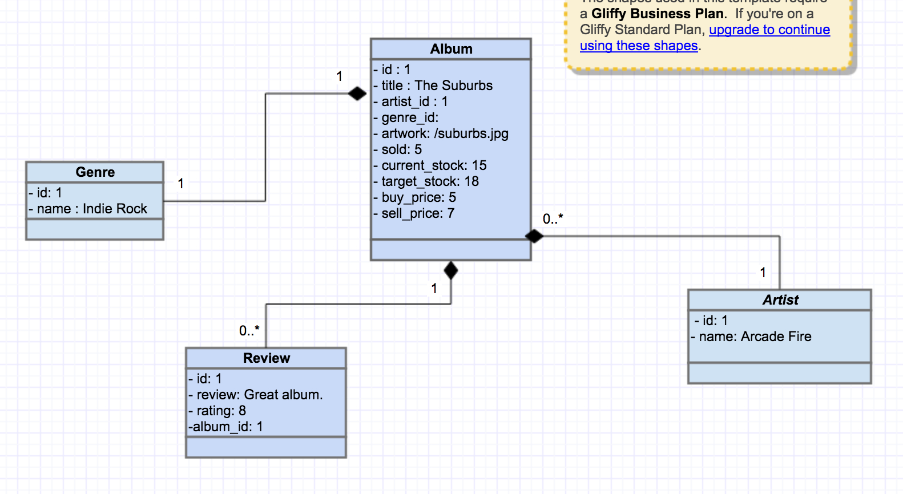

**AD 4 – Activity Diagram**

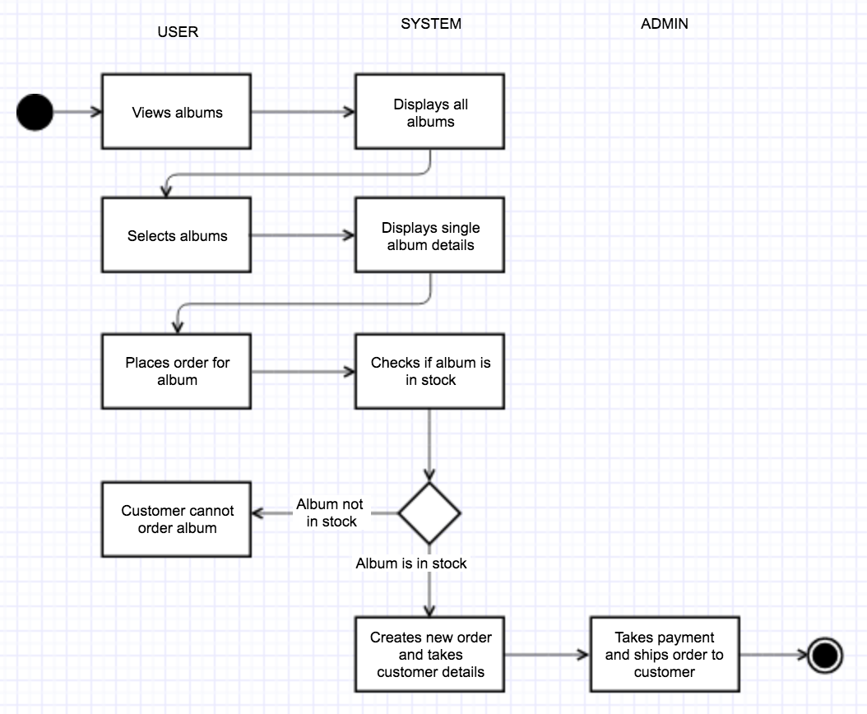

**AD 5 – Inheritance Diagram**

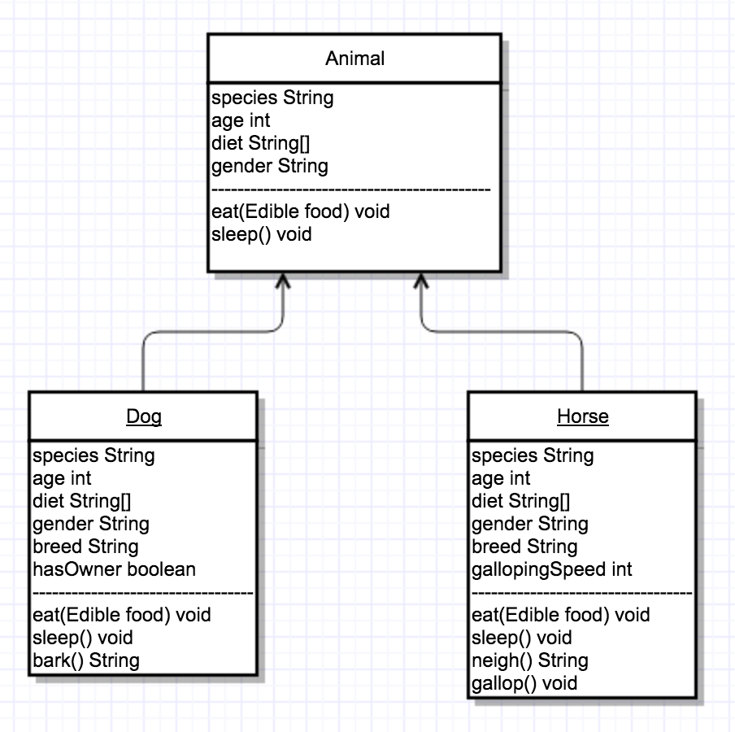

**AD 6 – Implementation Constraints**

|  |  |  |
| --- | --- | --- |
| **Constraint** | **Possible constraint** | **Details** |
| **Hardware and software platforms** | If the design of the UI is not responsive, then the product may be unusable on mobile and tablet devices. This would reduce the number of users and therefore revenue. | Ensure that flexbox and media queries are used to make the UI respond to the user’s device |
| **Performance requirements** | If the web server does not accommodate high levels of traffic, then increasing popularity of product may lead to slow performance or crashing, discouraging users from engaging with product. | Ensure server is designed to meet the expected level of traffic, and possibly use a cloud computing service to ensure scalability if user levels increase. |
| **Persistent storage and transactions** | Since this project made use of a simple database there were no storage problems; however if many more albums and transactions were processed this could lead to slower performance. | In this event then a larger, more robust database would be implemented. |
| **Usability** | It may be unclear to the user how to navigate the app and use its features, discouraging the user from continuing to use the application. | Add a navigation bar with clearly named titles for each module in the application, and an about page to explain the purpose of the application. |
| **Budgets** | As there was no budget used, functionality that could have been implemented was not. | This was not a problem due to this being a personal project. However, with a budget then more features could have been implemented to take the app past its Minimum Viable Product. |
| **Time** | This project was a week-long; therefore there were several features that were not implemented due to time constraints. | With more time these features could be implemented, leading to a better product and a more enjoyable experience for the user. |